**BUILDING DYNAMIC FRONTEND:**

**Objective**

On Day 4, I will focus on designing and building dynamic frontend components to display marketplace data fetched from Sanity CMS or APIs. This task will help me create modular, reusable components while gaining practical experience in developing scalable and responsive web applications.

**Key Learning Outcomes:**

1. Develop dynamic frontend components that retrieve and display data from Sanity CMS or APIs.
2. Create reusable and modular components to enhance maintainability and scalability.
3. Utilize state management techniques to control data flow across components.
4. Prioritize responsive design and implement UX/UI best practices.
5. Prepare for real-world client projects by mimicking professional workflows.

**Key Components to Build:**

1. **Product Listing Component:**

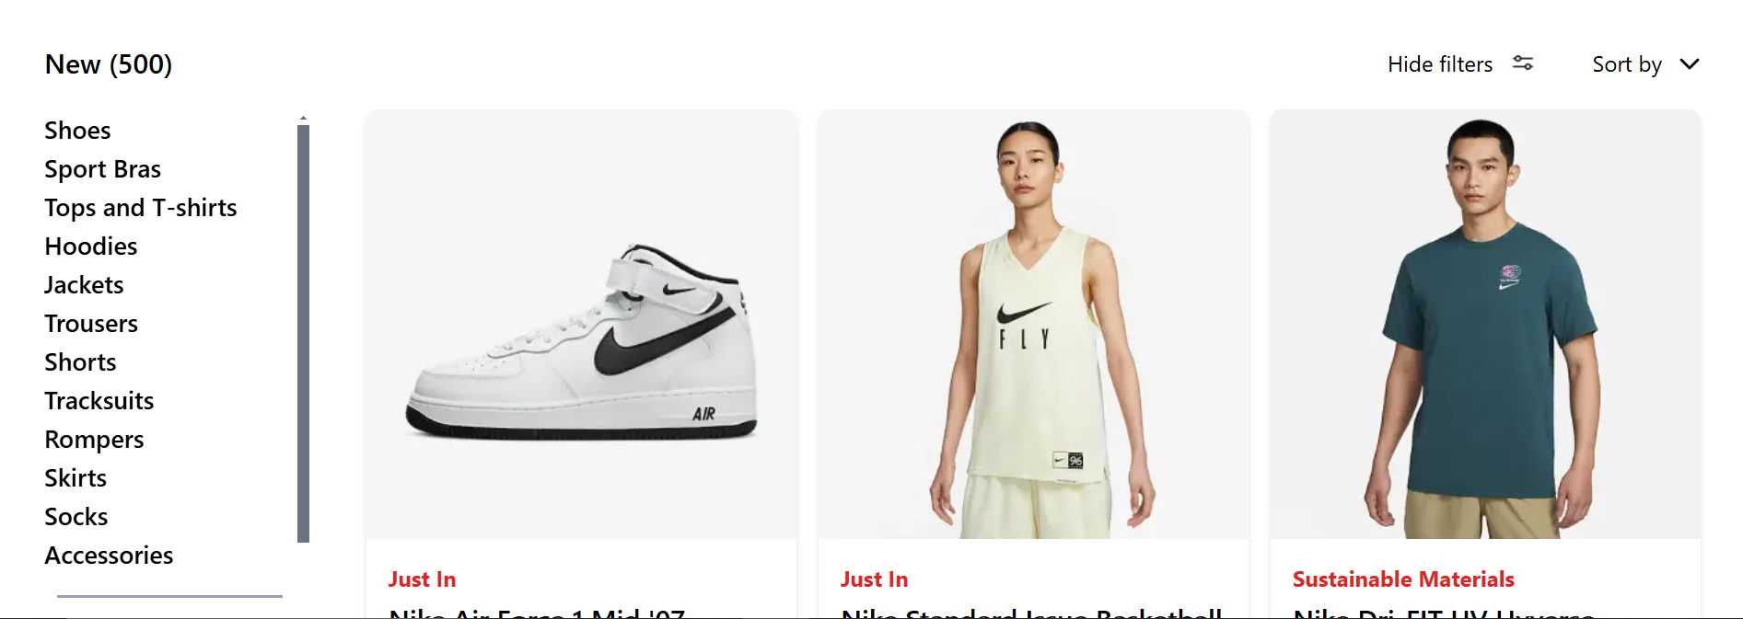

1. **Product Detail Component:**

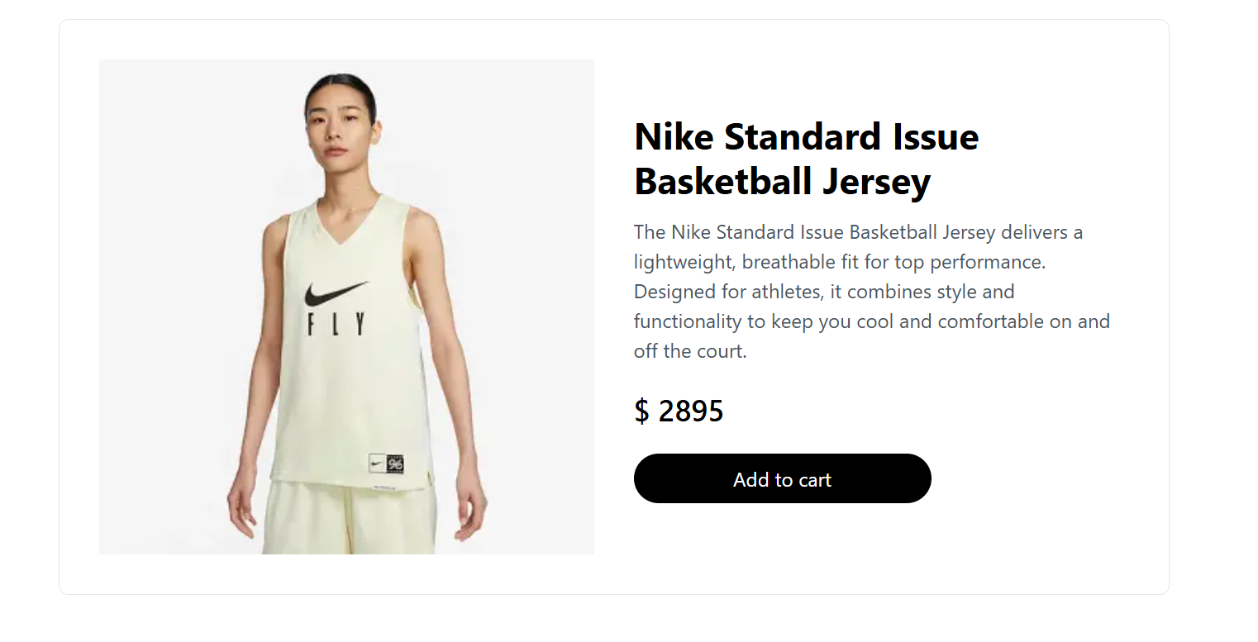

1. **Cart Component:**

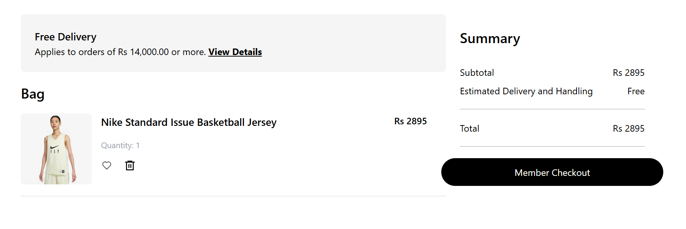

1. **Header Component:**



1. **Footer Component:**

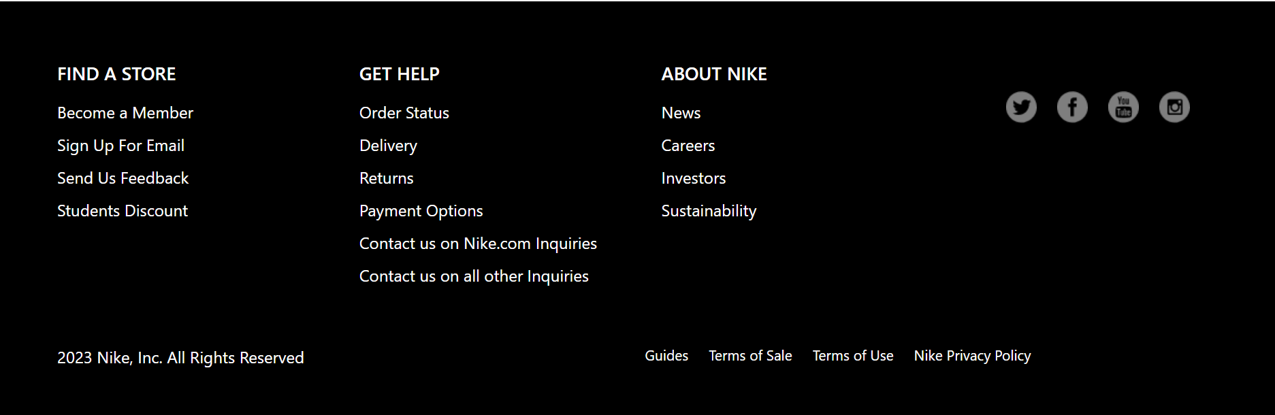

-

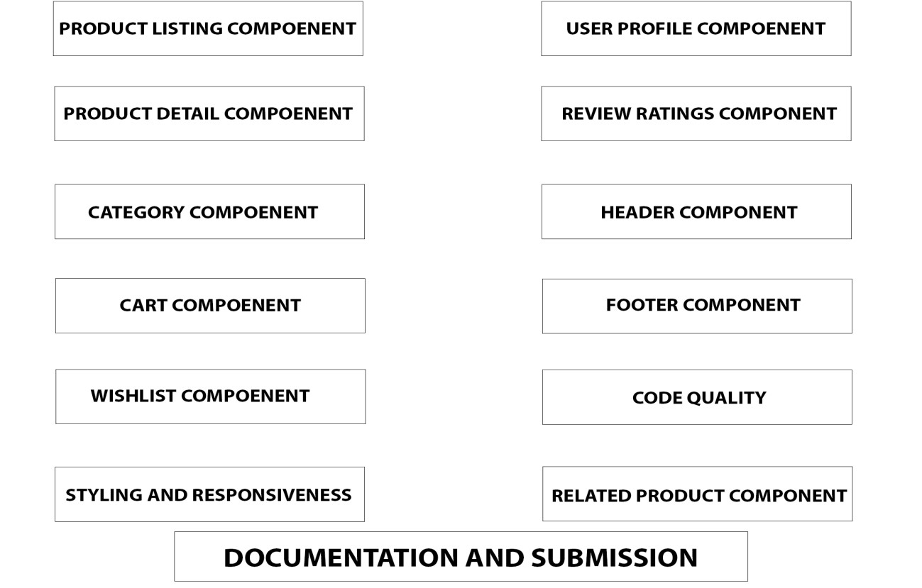

Conclusion:

During Day 4, students learned how to effectively create modular interactive frontend components to be consumed using real live data from the Sanity CMS or other APIs. The components that were built are ready for use because the students emphasized modularity, state management, responsive design, and other relevant parts in addition to best practices. Following the tips that have been provided to the students, they are now able to create dynamic and interactive web applications for real life problems.